ICS3U – FINAL PROJECT  
STEP 2 – ANALYSIS AND DESIGN

**APPLICATION SUB PROGRAMS**

1. List the various subprograms that you will create in your project.
2. Outline the purpose of each of the functions & procedures you mentioned from the previous point.
3. Remember that you are NOT writing computer code during this phase.

**DEVELOPMENT PLAN**

Outline the order that the functions and procedures will be created and a time-line for completion. List when you would like particular portions of your application complete.

|  |  |  |  |  |  |  |
| --- | --- | --- | --- | --- | --- | --- |
| **SUN** | **MON** | **TUE** | **WED** | **THUR** | **FRI** | **SAT** |
| 15 | 16 | 17 | 18 | 19 | 20 | 21 |
| 22 | 23 | 24 | 25 | 26 | 27 | 28 |
| 29 | 30 | 31  Finish inventory system | 1  **Step 1 Due** | 2 | 3  **Step 2 Due**  **Work Log 1**  Finish battle system | 4 |
| 5 | 6  **P.D. Day** | 7  Finish player classes and dungeon creation | 8 | 9 | 10  **Work Log 2** | 11  Finish adding all the dungeons, rooms, and enemy profiles |
| 12  Create a simple dungeon selection screen | 13 | 14  Finish adding all items into the game | 15  **Final Project Due** | 16 |  |  |

**PROBLEM SOLVING TOOLS**

1. Complete at least 2 of the following 3 problem solving tools.
   1. Create an IPO chart for one of your function or general sub procedures.
   2. Create a Flowchart for one of your function or general sub procedures.
   3. Create a solution for a function or procedure via an algorithm layout.

IPO - itemIndex

|  |  |  |
| --- | --- | --- |
| **Input** | **Processing** | **Output** |
| itemID (The number representing an item) | Using a case statement, go down the list of case is = 1 , 2 etc, until it reaches the item ID that matches, and then return a string value with the matching name. | String with the name of the item |

Flowchart – nxtRoom

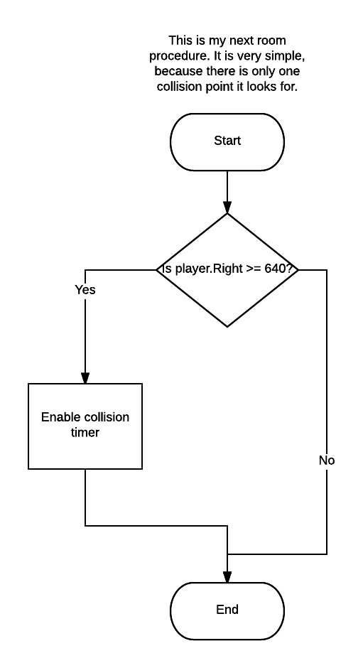

Submit this completed MS Word document on the D2L website to the drop box labelled “**Step 2 - Analysis and Design**” in the Final Project folder. This needs to be submitted, prior to moving on to Step 3.